Courtney Alt

Advanced Academic Resource Teacher CMAlt1@fcps.edu

Welcome to the new school year!

My role as AART is to support the implementation of the continuum of Advanced Academic Services. Please refer to the information on this page, which details Level I through Level IV services for elementary students. For more detailed infor- mation on the FCPS Advanced Academic Programs, please visit
their website at https://www.fcps.edu/
Hunt Valley Elementary Advanced Academic Program

Young Scholars, K-12 (All Levels)
FCPS Advanced Academic Elementary Programs
AAP Overview Q&A Sessions
Wed. Sept. 23rd 10—11am Wed. Sept. 30th 11am-12pm
All AAP Questions Q&A Session:
Tues., Oct. 6th 6-7pm
Level IV Screening and Referral Q&A Session:
Fri, Oct. 2nd 12:30—1:30pm Tues, Nov. 10th 12-1 pm Wed, Nov. 18th 12-1 pm Tues, Nov. 24th 1-2pm
All Sessions on BBCU - Link: https://bit.ly/3hGB7oL

S E P T E M B E R 2 0 2 0

Level IV referral deadlines for the 2020-2021 school year:

Fall deadline ( those new to FCPS since January 1, 2020) - October 8,
2020

Spring deadline (for those seeking placement in the 2021-2022 school year) - December 1, 2020
**There are some adjustments to the AAP Level IV screening processes for the 20-21 school year.

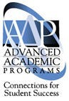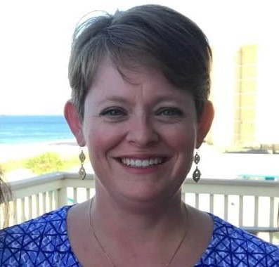academics/elementary-school-academics- k-6/advanced-academics

Screening for Advanced Academic services is also an important part of my role at Hunt Valley. I’ll be hold- ing Q & A sessions at various times this fall where parents can come and ask about our programs and screen- ing processes.
I’ll continue teaching critical and creative thinking lessons, planning with teachers in Collaborative Learning Team meetings, pulling small groups of students who receive services, and working with teachers in all classrooms to support our school goal of providing all students with access to AAP Curriculum.
I look forward to working with you and your child this year!
Young Scholars is designed to find and nurture advanced academic potential in students from historically un- derrepresented populations. Curricular interventions and support are provided through the collaboration of the classroom teacher and the advanced academic resource teacher.
Critical and Creative Thinking Strategies, Grades K-6 (Level I)
The advanced academic resource teacher and classroom teachers teach nine higher order thinking strategies across all subject areas and grade levels. The strategies are embedded in lessons that incorporate 21st Century thinking skills and extend and enrich the Program of Studies (POS) for all learners. Student responses to the lessons are also used to collect evidence of advanced academic potential in order to ensure equity and increase access to advanced academic programs.
Differentiated Lessons in Areas of Academic Strength, Grades K-6 (Level II)
Differentiated lessons are offered to students in areas of specific academic strength. The advanced academic resource teacher collaborates with classroom teachers to provide additional challenge through resources that extend and enrich the FCPS Program of Studies.
Part-Time Advanced Academic Program, Grades 3-6 (Level III)
Students identified by a local school screening committee for advanced academic services (Level III) are chal- lenged through models and strategies designed to extend and enrich the POS in the four core subject areas. Students receive direct instruction from the advanced academic resource teacher in one or more areas of aca- demic strength at their local schools.
Full-Time Advanced Academic Program, Grades 3-8 (Level IV)
Students found eligible for placement in a full-time Advanced Academic Program (Level IV) through a central selection process receive a highly challenging instructional program in the four core subject areas. The Level IV program is designed to meet the needs of advanced learners with a strong emphasis on higher level thinking, problem-solving, and decision-making. Students have ongoing opportunities for reflection that develop an understanding of the characteristics, demands, and responsibilities of advanced intellectual development.
Ability Testing
The CogAt test will not be offered this school year. There will be a process for students without an abilities test on file to take the NNAT in December 2020. We will reach out to families to schedule safe and socially distanced testing.
The one-time retest option for the NNAT or CogAt will not be available this school year. At this time, 1st graders will be taking the NNAT in the Spring, testing date TBD.

